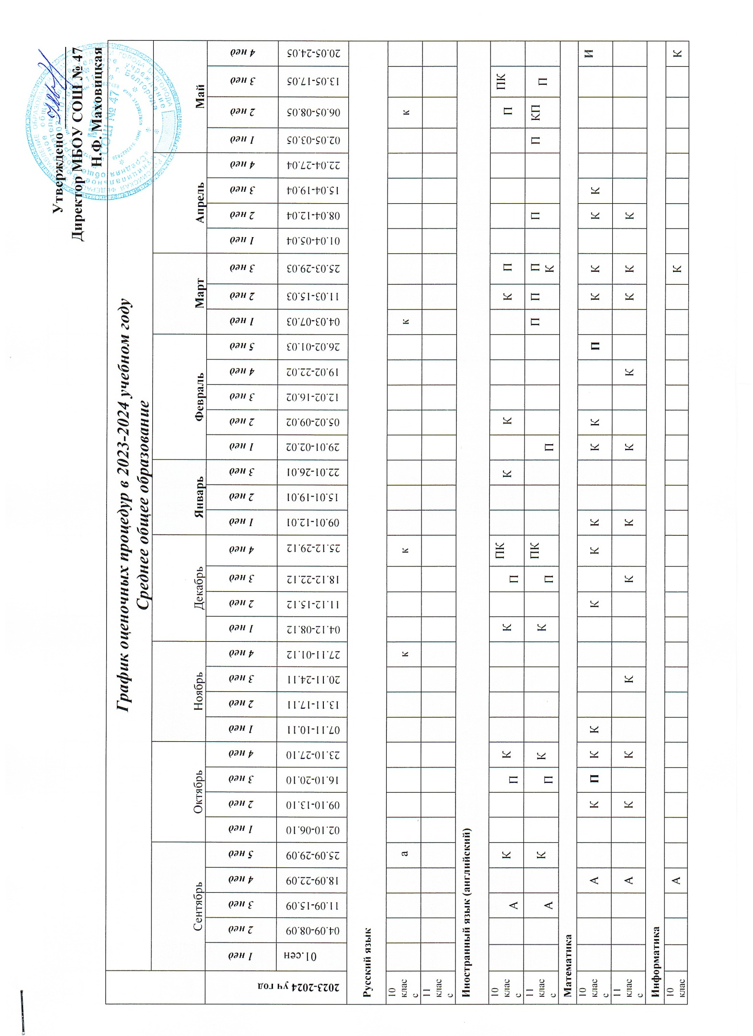

|  |  |  |  |  |  |  |  |  |  |  |  |  |  |  |  |  |  |  |  |  |  |  |  |  |  |  |  |  |  |  |  |  |  |  |  |  |
| --- | --- | --- | --- | --- | --- | --- | --- | --- | --- | --- | --- | --- | --- | --- | --- | --- | --- | --- | --- | --- | --- | --- | --- | --- | --- | --- | --- | --- | --- | --- | --- | --- | --- | --- | --- | --- |
| 11 класс |  |  |  |  |  |  |  |  |  |  |  |  |  |  |  |  |  |  |  |  |  |  |  |  |  |  |  |  |  |  |  |  |  |  | З | З |
| **География** | | | | | | | | | | | | | | | | | | | | | | | | | | | | | | | | | | | | |
| 10 класс |  | П |  | П |  | П | П | П |  |  |  | П | П | П | П |  | П | П |  | П |  |  |  |  | П |  |  |  |  |  | П |  |  |  |  |  |
| **Физика** | | | | | | | | | | | | | | | | | | | | | | | | | | | | | | | | | | | | |
| 10 класс |  |  | А |  |  |  |  |  |  |  | Л | К |  |  |  | Л |  |  |  |  | К |  |  |  |  |  |  |  |  |  |  |  |  |  | К |  |
| 11 класс |  |  | А |  | Л | К |  |  |  |  |  | К |  |  |  |  |  | Л | К |  |  |  | Л | К |  |  |  |  |  | К |  |  |  |  |  |  |
| **История** | | | | | | | | | | | | | | | | | | | | | | | | | | | | | | | | | | | | |
| 10 класс |  |  |  | А |  |  |  |  |  |  |  | К |  |  |  |  |  |  | К |  |  |  |  |  |  |  |  |  |  |  |  |  |  |  |  | К |
| 11 класс |  |  | А |  |  |  |  |  |  |  |  |  |  |  |  |  |  |  |  |  |  |  |  | К |  |  |  |  |  |  |  | К |  |  |  | К |
| **Обществознание** | | | | | | | | | | | | | | | | | | | | | | | | | | | | | | | | | | | | |
| 10 класс |  |  |  | А |  |  |  |  |  |  |  | К |  |  |  |  |  |  | К |  |  |  |  |  |  |  |  |  |  |  |  |  |  |  | П | П |
| 11 класс |  |  | А |  |  |  |  |  |  |  |  |  |  | К |  |  |  |  |  |  |  | К |  |  |  |  |  |  |  |  |  |  |  | К |  |  |
| **Физическая культура** | | | | | | | | | | | | | | | | | | | | | | | | | | | | | | | | | | | | |
| 10 класс |  |  |  |  |  |  | К | Н |  |  |  |  |  |  |  |  |  |  |  |  |  |  |  |  |  |  |  |  |  |  |  | К | К | К | К | К |
| 11 класс |  |  | З | К | К |  |  |  |  |  |  | К |  |  |  |  |  |  |  |  |  |  |  |  |  |  |  |  |  |  |  | К |  | З | К | З |
| **ОБЖ** | | | | | | | | | | | | | | | | | | | | | | | | | | | | | | | | | | | | |
| 10 класс |  |  |  |  |  |  |  | к |  |  |  |  |  |  |  |  |  |  |  |  |  |  |  |  |  |  |  |  |  |  |  |  |  |  |  |  |
| 11 класс |  |  | З | К | К | К |  |  |  |  |  |  | К |  |  |  |  |  |  |  |  |  |  |  |  |  |  |  |  |  |  | К |  | З | К | К |
|  | **А** | Административная контрольная работа |  | И | Итоговая контрольная работа |  | К | Контрольная работа |  | **П** | **П**рактическая работа |  |  |  |  |  |  |  |  |  |  |  |  |  |  |  |  |  |  |  |  |  |  |  |  |  |